|  |  |
| --- | --- |
| Nature |  |
| **Titre  *Title*** | **WEST ICRH Antenna Reference RF Model** |
| Auteur(s)  *Author(s)* | Julien Hillairet |
| Catégorie  *Category* |  |
| Référence(s) | A remplir |
| Version | 1.0 |

|  |  |
| --- | --- |
| Résumé *Abstract* | This note details the RF model of the WEST ICRH Antenna. |
| Destinataires *Addressees* |  |

|  |  |  |
| --- | --- | --- |
|  | Signé par procédure électronique GEDI par  *Signed by electronic Workflow by* | Date |
| Auteur(s)  *Author(s)* | P. NOM | dd/mm/aa |
| Vérificateur(s)  *Reviewer(s)* | P. NOM | dd/mm/aa |
| Approbateur(s)  *Approver(s)* | Rang 1 : P. NOM | dd/mm/aa |
| Rang 2 : P. NOM | dd/mm/aa |

Historique des versions approuvées/Approved versions history

|  |  |  |  |  |
| --- | --- | --- | --- | --- |
| **Indice de version**  *Version* | **Date** | **Auteur(s)**  *Author(s)* | **Pages ou paragraphes modifiés**  *Pages or paragraphs changed* | **Nature des modifications**  *Nature of the changes* |
| 1.0 |  |  | Toutes | Première émission du document |
|  |  |  |  |  |
|  |  |  |  |  |
|  |  |  |  |  |

***Version non contrôlée lorsqu’elle est imprimée ou téléchargée depuis GEDI.***

**L’utilisateur est responsable de vérifier qu’il utilise la bonne version à l’aide de GEDI.**

***Revisions uncontrolled when printed or downloaded from IRFM DMS (GEDI).***

**It is the responsibility of user to ensure that he is using the last revision uploaded in the IRFM DMS (GEDI).**

Sommaire

1 Objet du document 3

2 Documents de reference 3

3 Glossaire et abreviations 3

4 Titre 1 3

4.1 Titre 2 3

4.1.1 Titre 3 3

# Service Stub

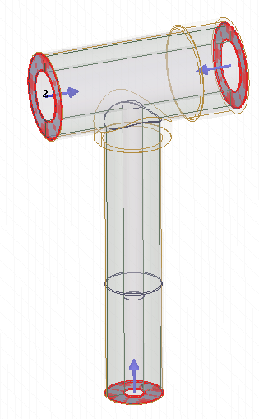

Figure 1. Service-stub RF Model

|  |  |  |  |
| --- | --- | --- | --- |
| Port Name (description) | Dint/Dout (mm) | Z0 (Ohm) | Deembedding (mm) |
| Port1 (generator side) | 140/230 | 29.8 | 100 |
| Port2 (window side) | 140/230 | 29.8 | 100 |
| Port3 (stub side) | 55.5/152 | 60.4 | 100 |

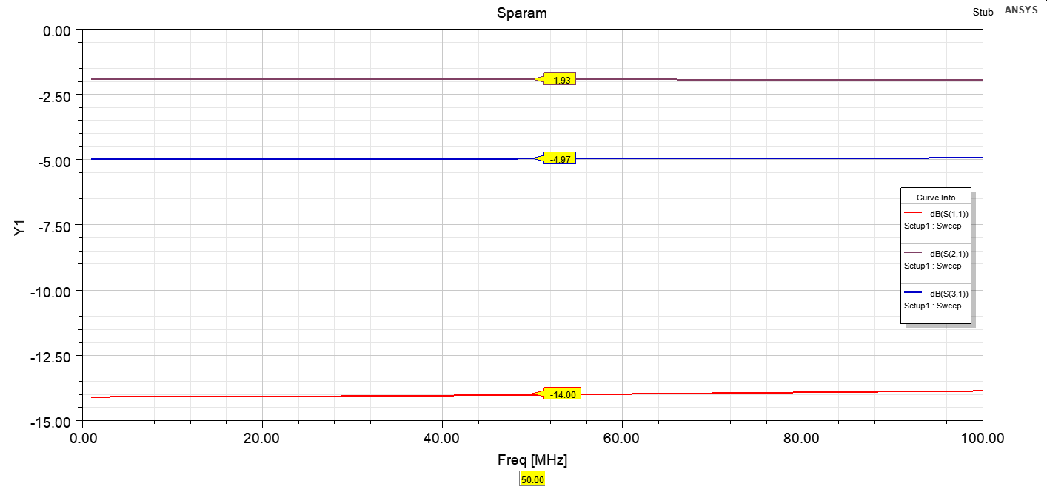

Figure 2. S-parameters of the service-stub

(The frequency response of the transmission being small, the stub can be eventually removed from the antenna model)

# Window and Impedance Transformer

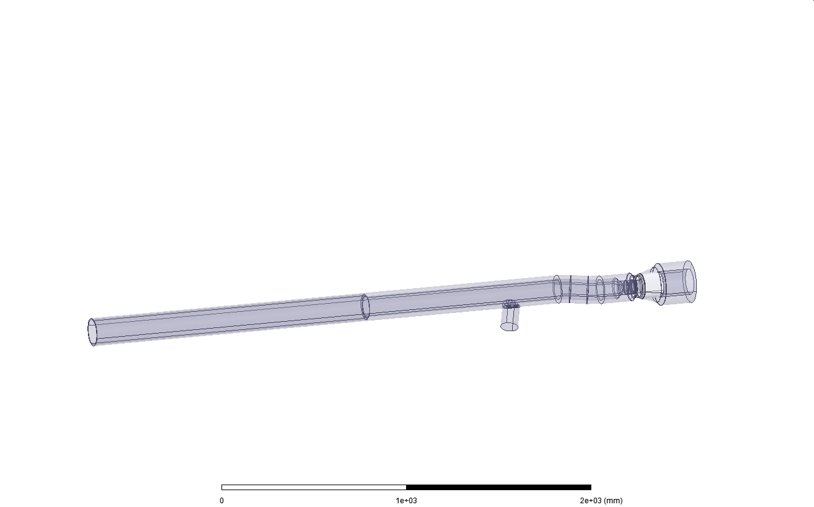

Port2

Port1

Figure 3. Window and Impedance Transformer (with pumping hole)

|  |  |  |
| --- | --- | --- |
| Port Name (description) | Dint/Dout (mm) | Z0 (Ohm) |
| Port1 (generator side) | 139.7/230 | 29.9 |
| Port2 (bride side) | 140/153 | 5.3 |

The conductors are designed in silver (HFSS material), so the RF losses on both internal and external conductors are taken into account. The window is modelled in Alumina.

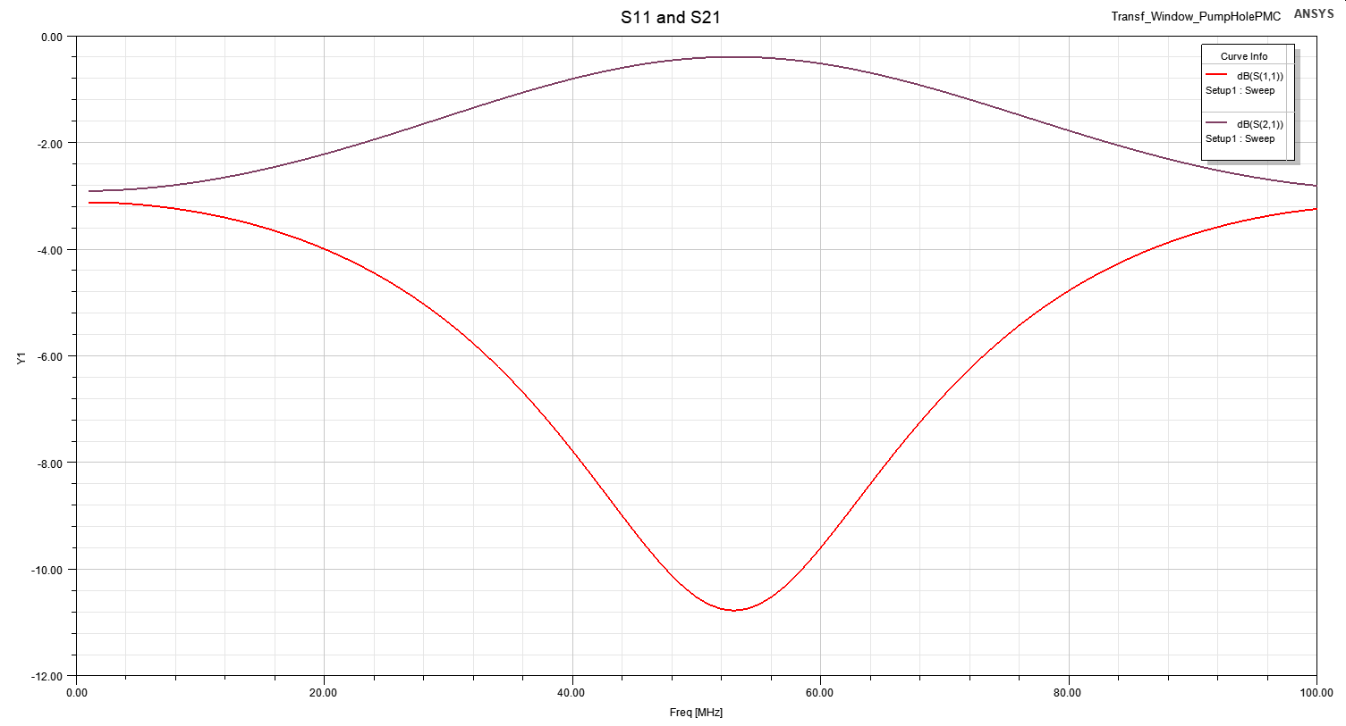

Figure 4. S11 and S21

# Bridge

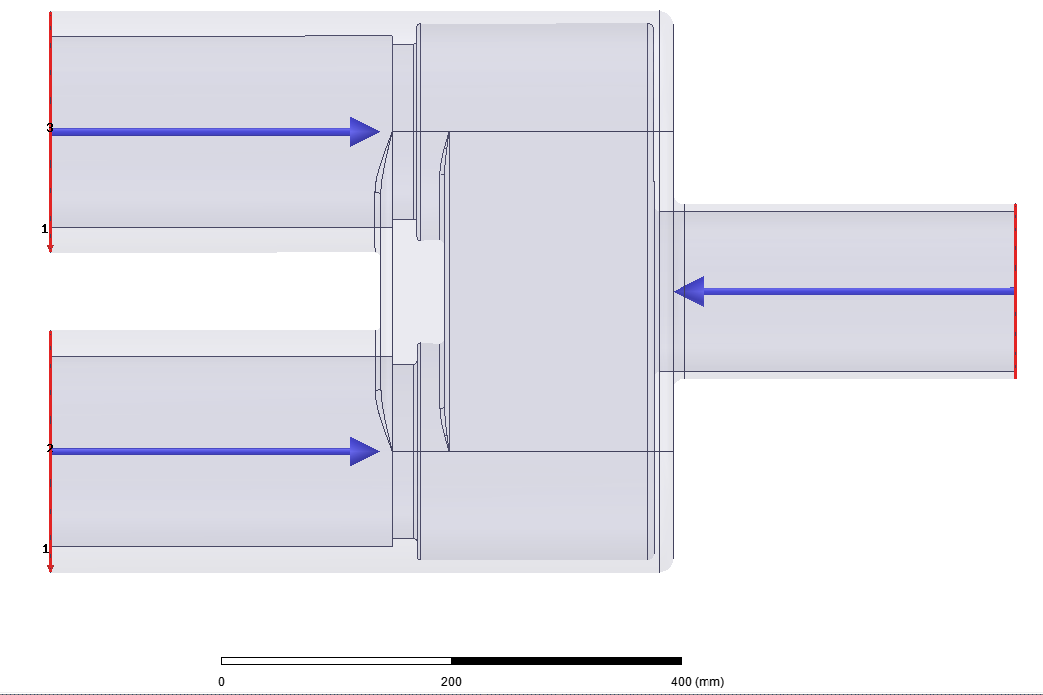

Figure 5. RF Model

|  |  |  |  |
| --- | --- | --- | --- |
| Port Name (description) | Dint/Dout (mm) | Z0 (Ohm) | Deembbed [mm] |
| Port1 (generator side) | 140/153 | 5.3 | 300 |
| Port2 (capacitor side, top) | 167/212 | 14.3 | 288.73 |
| Port3 (capacitor side, bottom) | 167/212 | 14.3 | 288.73 |

# 

Figure 6. bridge RF model main dimensions. Port 1 is deembedded by a distance of 316.62-16.62 = 300mm and ports2&3 by 288.73mm

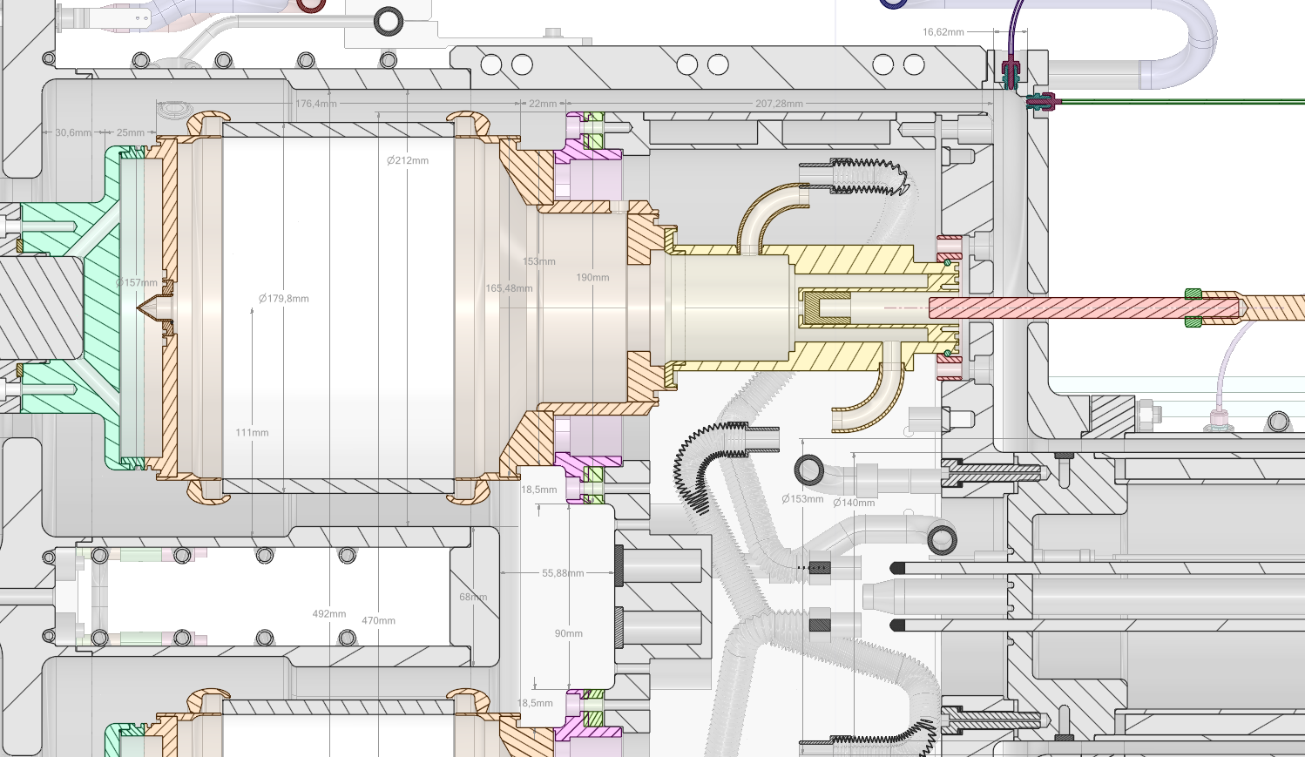

Figure . Quelques dimensions dans la région du bridge from CAD

# Capacitors

The capacitor is modelled inside its housing box in order to model its operational behavior (Figure 3). Ports size are:

|  |  |  |
| --- | --- | --- |
| Port Name (description) | Dint/Dout (mm) | Z0 (Ohm) |
| Port1 (bridge side) | 180/212 | 9.8 |
| Port2 (strap side) | 102/222 | 46.6 |
| Port3 (voltage probe) | 3/7 | 50.8 |

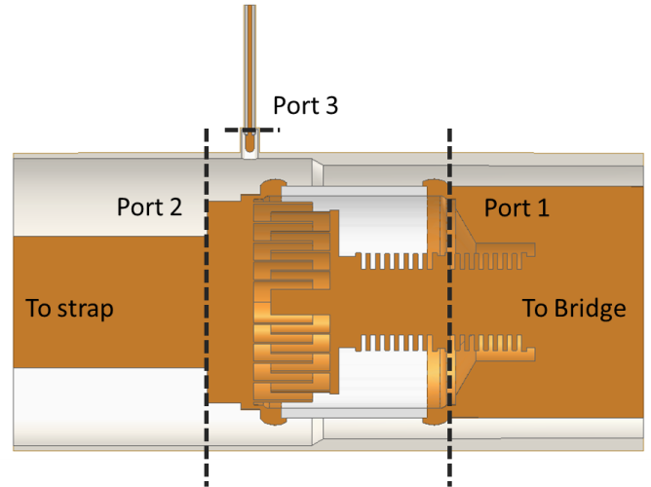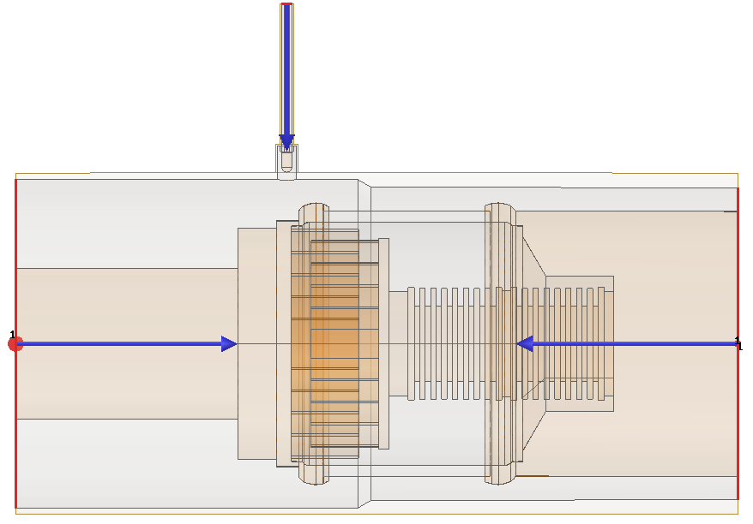

Figure 8. Left: RF model of the capacitor (cut). Right: Port de-embbeding setup with Port#1 150mm, Port#2 150mm, Port#3 150mm. Characteristic Impedances are renormalized to 50 Ohm.

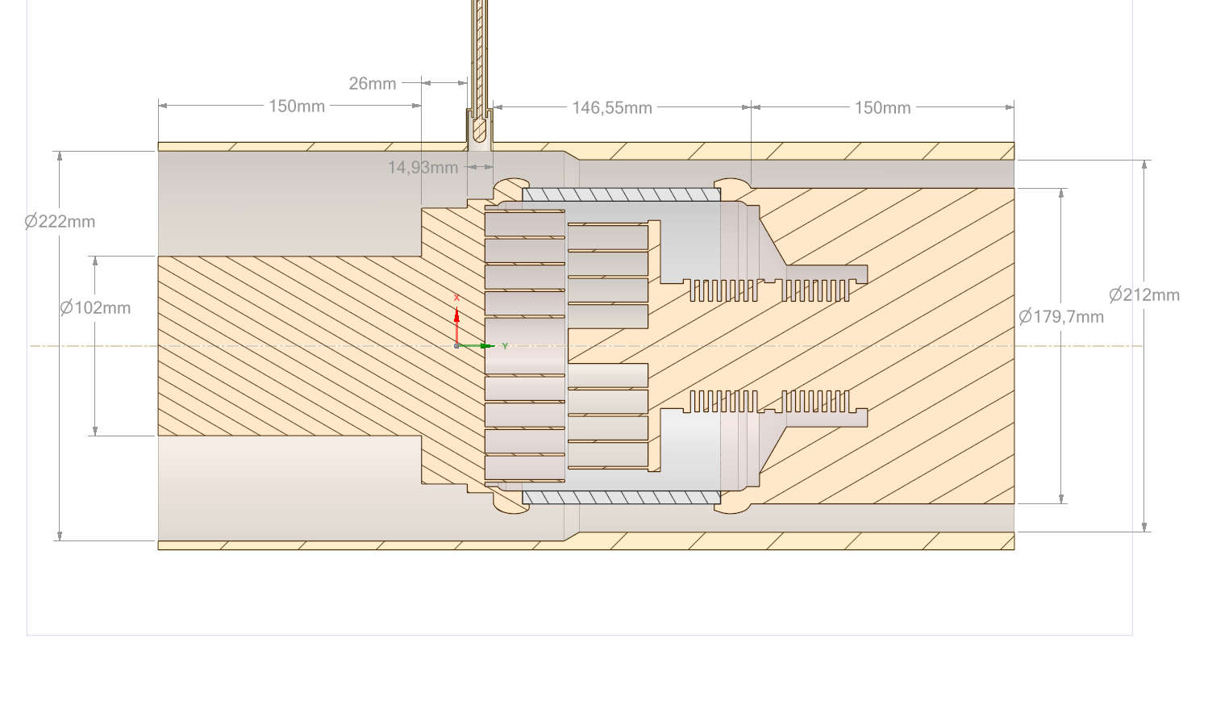

Figure . RF Model main dimensions

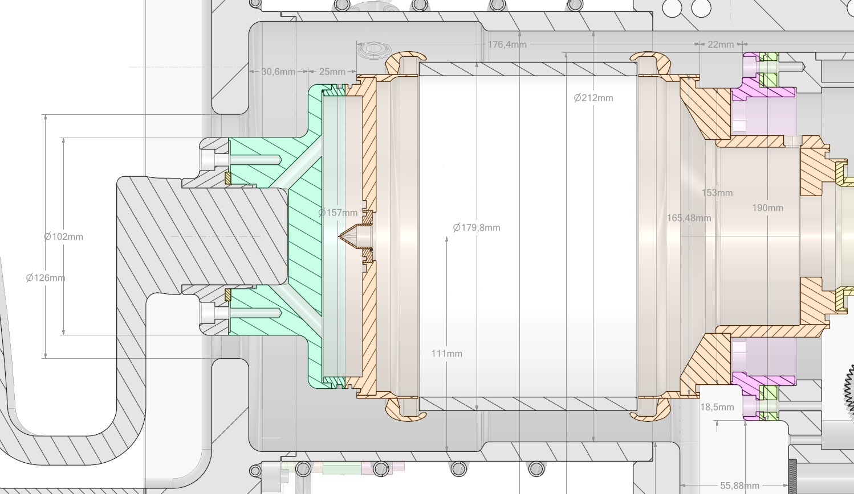

Figure 10. CAD model main dimension around strap/capacitor interface

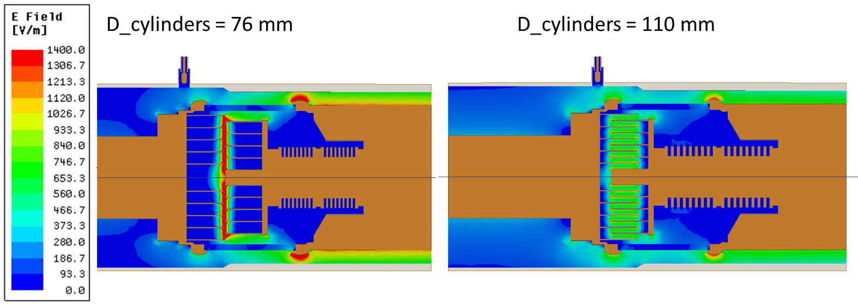

Figure 11. Left: max capacitance. Right: min capacitance.

# Antenna Front Face

The antenna front face, which contains the housing box, the faraday screen and the straps, has been modelled as pure silver components (silver material definition from HFSS). The antenna has been setup in front of a vacuum box with radiating boundary conditions.

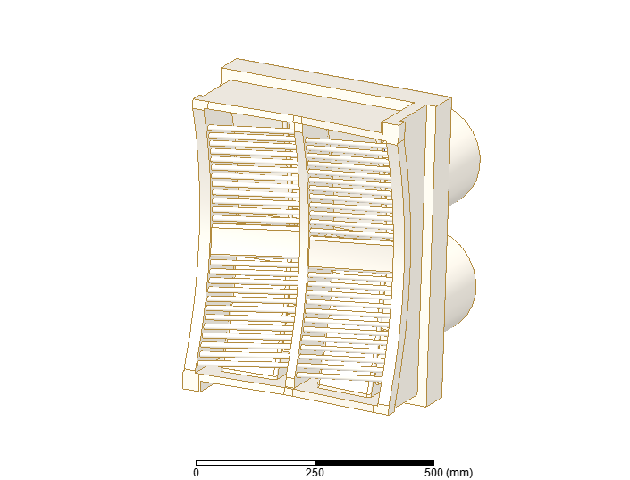

Figure 12. Antenna Front Face RF CAD model.

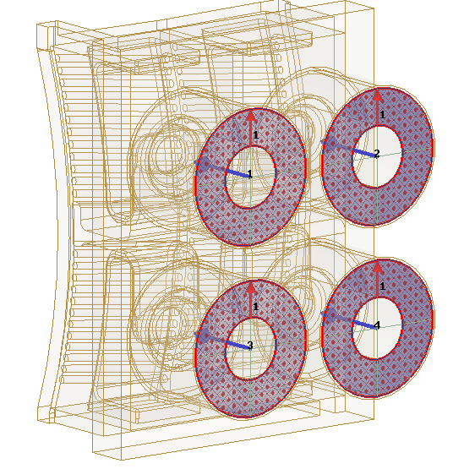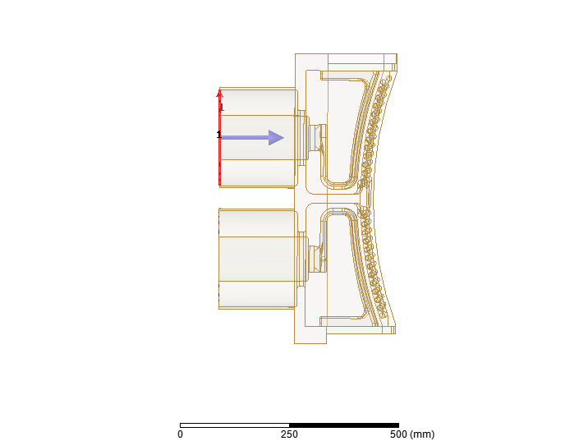

Figure 13. Port numbering. Ports are de-embedded by a distance of 150 mm.

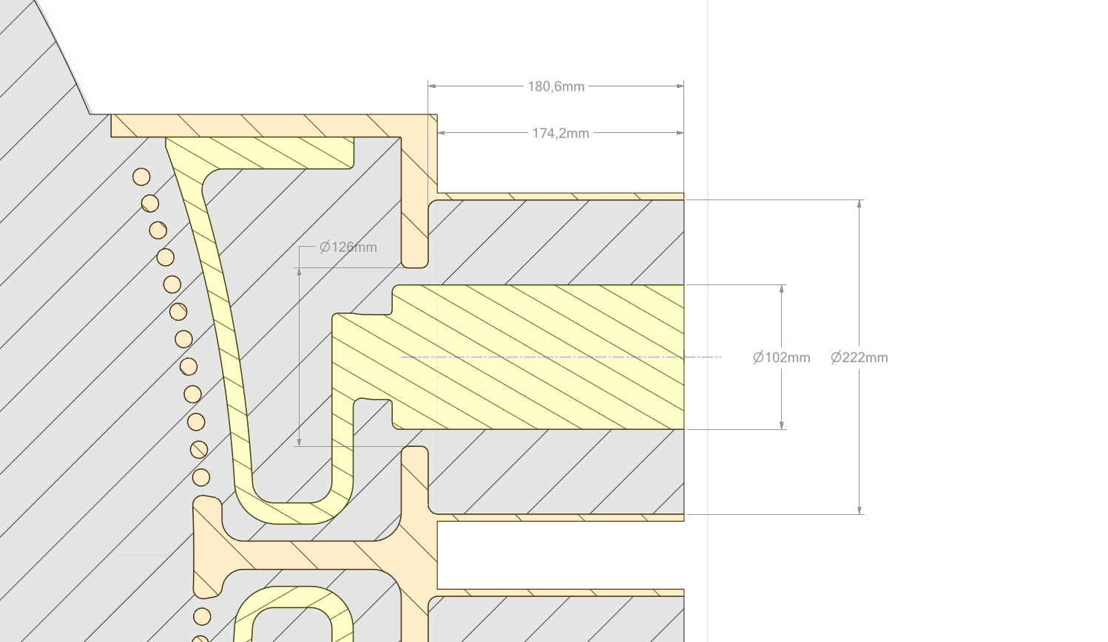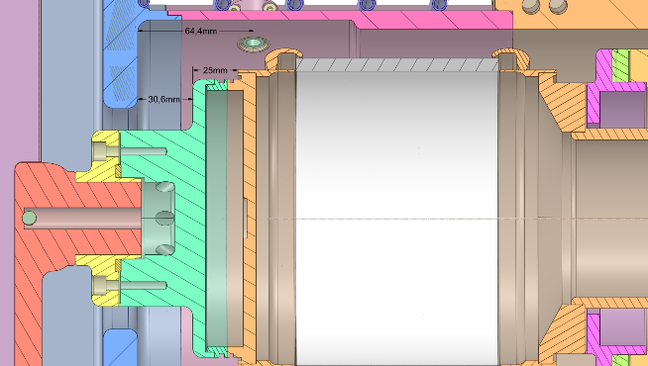

30.6

Figure 14. RF Model interface main dimensions and CAD model. Port interface is located at 30.6 mm from the outer conductor, which corresponds to the interface with the capacitor. 180.6-30.6=150 mm.

|  |  |  |  |
| --- | --- | --- | --- |
| Port Name (description) | Dint/Dout (mm) | Z0 (Ohm) | Deembedding [mm] |
| Port1 | 102/222 | 46.6 | 150 |
| Port2 | 102/222 | 46.6 | 150 |
| Port3 | 102/222 | 46.6 | 150 |
| Port4 | 102/222 | 46.6 | 150 |

Given this de-embedding length of 150 mm, the strap reactance best polynomial fit leads to (see dedicated notebook for details):

Xs(fMHz) = 1.66e-04 fMHz3 -1.53e-02 fMHz2 + 1.04 fMHz -7.77

# Antenna Model

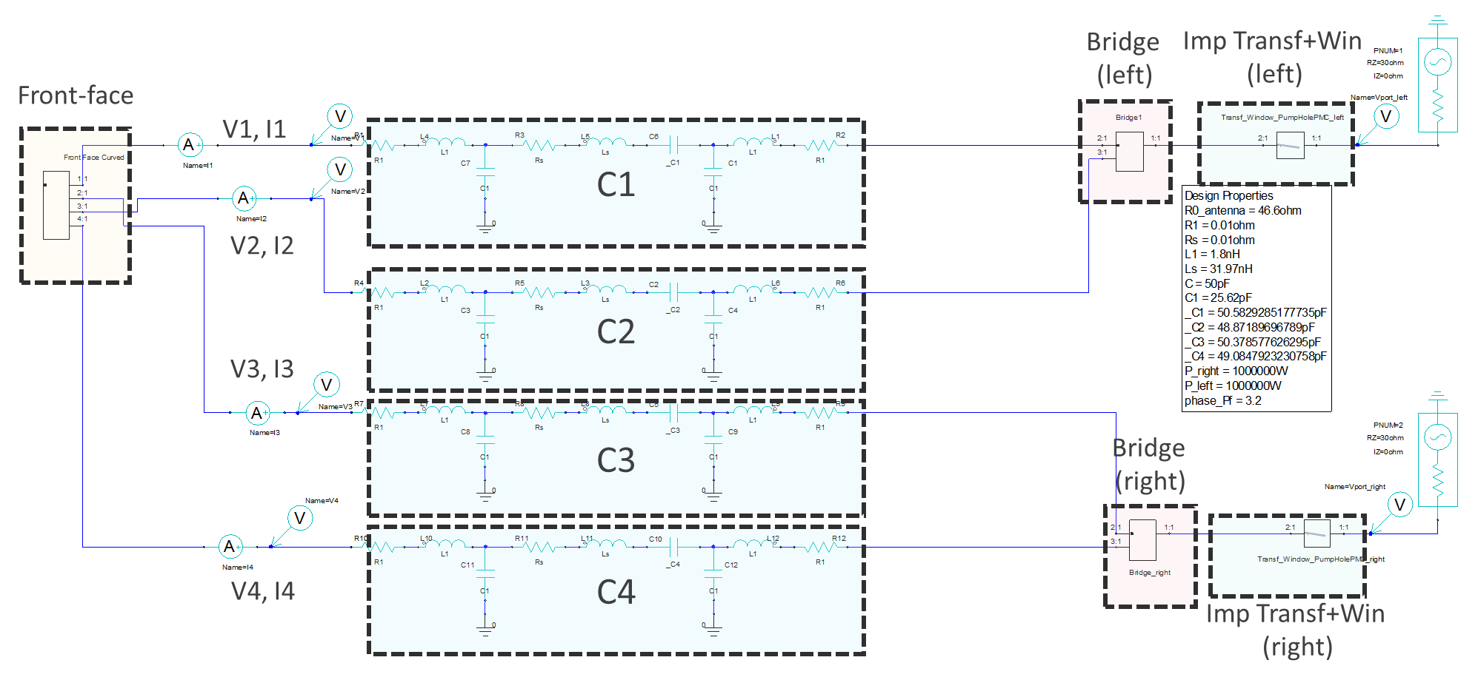

Figure 15. WEST ICRH ANSYS Circuit Antenna Circuit

The WEST ICRH capacitors are modelled by an equivalent lump circuit, which has been synthetized from full-wave modelling of the capacitor [1]. The voltages and currents at each port of the antenna front face are measured. The location of this measurement is close to the real location.

## Antenna Manuel Matching Procedure

The antenna setup in dipole excitation is made as in reality [2]:

1. Left side is matched @55MHz, right side unmatched -> optimisation gives C1, C2 (C1>C2)
2. Right side matched @55MHz, left side unmatched -> optimisation gives C2, C3 (C2>C3)
3. C1-C4 are set to their optimized values
4. Frequency is shifted to higher value: @55.22 MHz, corresponding to the optimum frequency for dipole excitation.
5. The difference between capacitances are eventually increased to play on the load tolerance response.

# References

[1] J. Hillairet, P. Bonoli, R. Pinsker, et X. Wang, « RF network analysis of the WEST ICRH antenna with the open-source python scikit-RF package », *AIP Conference Proceedings*, vol. 2254, no 1, p. 070010, sept. 2020, doi: 10/ghbw5p.

[2] W. Helou *et al.*, « Characterizations and first plasma operation of the WEST load-resilient actively cooled ICRF launchers », *AIP Conference Proceedings*, vol. 2254, no 1, p. 030009, sept. 2020, doi: 10/ghbw5v.